Chapter 8: Incremental Analysis

8-1
At 10%, select Edmonton.

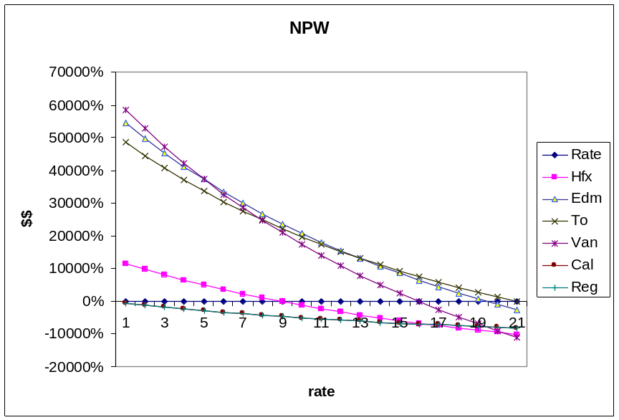

8-2
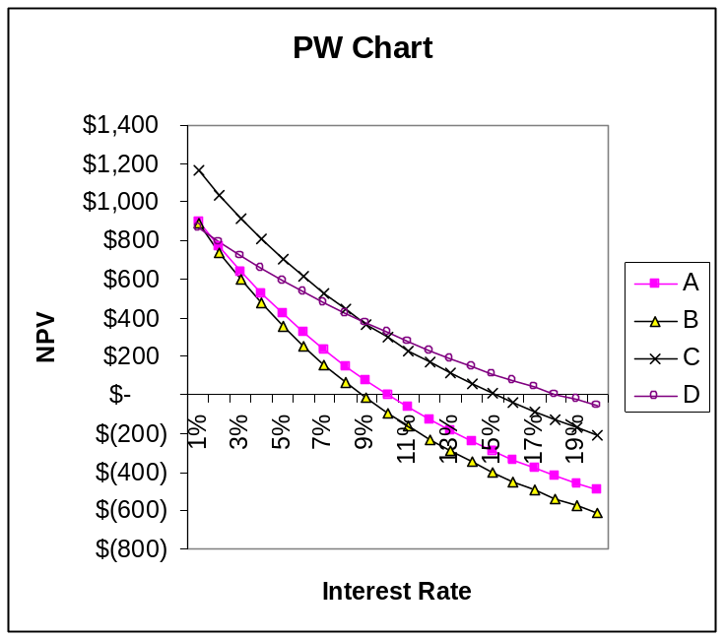



8-3
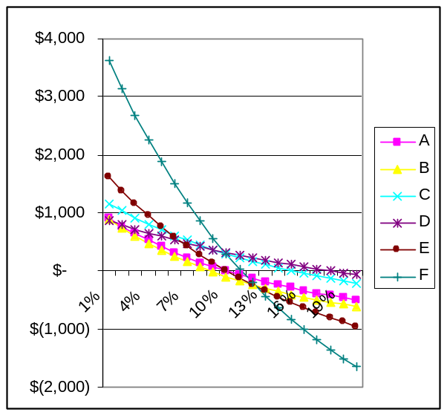



8-4
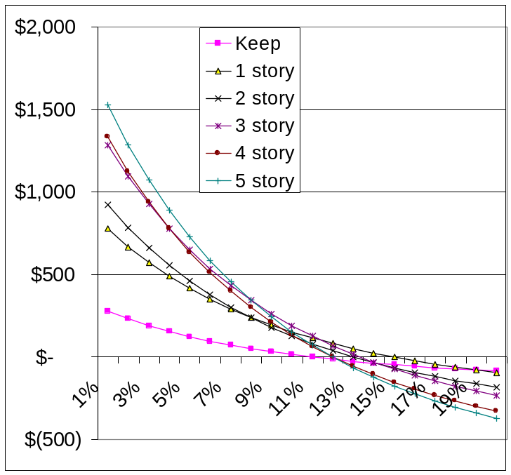

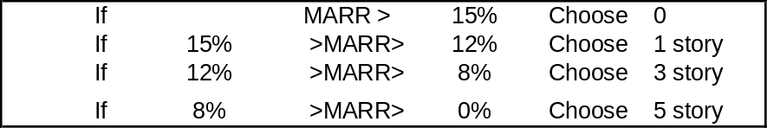

8-5
Plan | Cost of Improvements and Land | Net Annual Income | Salvage Value | Computed Rate of Return | Decision
A | $145,000 | $23,300 | $70,000 | 15% | Accept
B | $300,000 | $44,300 | $70,000 | 12.9% | Accept
C | $100,000 | $10,000 | $70,000 | 9% | Reject - fails to meet the 10% criterion
D | $200,000 | $27,500 | $70,000 | 12% | Accept

Rank the three remaining projects in order of cost and examine each separable increment of investment.

Plan D rather than Plan A

∆ Investment | ∆ Annual Income | ∆ Salvage Value
$55,000 | $4,200 | $0

$55,000 = $4,200 (P/A, i%, 15)

(P/A, i%, 15) = $55,000/$4,200 = 13.1

From interest tables: i = 1.75%

This is an unacceptable increment of investment. Reject D and retain A.

Plan B rather than Plan A

∆ Investment | ∆ Annual Income | ∆ Salvage Value
$155,000 | $21,000 | $0

$155,000 = $21,000 (P/A, i%, 15)
(P/A, i%, 15) = $155,000/$21,000 = 7.38

From interest tables: i = 10.5%

This is a desirable increment of investment. Reject A and accept B.

Conclusion: Select Plan B.

8-6
Year | Plan A Cash Flow | Plan B Cash Flow | Plan B Rather than Plan A | Plan C Cash flow | Plan C rather than Plan B
0 | -$10,000 | -$15,000 | -$5,000 | -$20,000 | -$5,0000
1-10 | +$1,625 | $1,625 | $0 | +$1,890 | +$265
10 | -$10,000 | $0 | +$10,000 | $0 | $0
11-20 | +$1,625 | +$1,625 | $0 | +$1,890 | +$265
Rate of Return | 10%* | 8.8% | 7.2%** | 7% | 0.6%***

*The computation may be made for a 10-year period:
$10,000 = $1,625 (P/A, i%, 10) i = 10%
The second 10-year period has the same return.

**The computation is:
$5,000 = $10,000 (P/F, i%, 10)
(P/F, i%, 10) = $5,000/$10,000 = 0.5 i = 7.2%

***The computation is:
$5,000 = $265 (P/A, i%, 20) i = 0.6%

The table above shows two different sets of computations.
1. The rate of return for each Plan is computed.

Plan | Rate of Return
A | 10%
B | 8.8%
C | 7%

2. Two incremental analyses are performed.

Increment | Rate of Return
Plan B – Plan A | 7.2% | A desirable increment. Reject Plan A. Retain Plan B.
Plan C – Plan B | 0.6% | An undesirable increment. Reject Plan C. Retain Plan B.

Conclusion: Select Plan B.

8-7
Looking at Alternatives B & C it is apparent that B dominates C. Since at the same cost B produces a greater annual benefit, it will always be preferred over C. C may, therefore, be immediately discarded.

Alternative | Cost | Annual Benefit | ∆ Cost | ∆ Annual Benefit | ∆ Rate of Return | Conclusion
B | $50 | $12
A | $75 | $16 | $25 | $4 | 9.6% | This is greater than the 8% MARR. Retain A.
D | $85 | $17 | $10 | $1 | 0% | < 8% MARR. Retain A.

Conclusion: Select Alternative A.

8-8
Like all situations where neither input nor output is fixed, the key to the solution is incremental rate of return analysis.

Alternative: | A | B | C
Cost | $200 | $300 | $600
Annual Benefit | $59.7 | $77.1 | $165.2
Useful Life | 5 yr | 5 yr | 5 yr
Rate of Return | 15% | 9% | 11.7%

 | B – A | C – B | C – A
∆ Cost | $100 | $300 | $400
∆ Annual Benefit | $17.4 | $88.1 | $105.5
∆ Rate of Return | < 0% | 14.3% | 10%

Knowing the six rates of return above, we can determine the preferred alternative for the various levels of MARR.

MARR | Test: Alternative Rate of Return | Test: Examination of separable increments
0% < MARR < 9% | Reject no alternatives. | B – A increment unsatisfactory  C- A increment satisfactory  Choose C.
9% < MARR < 10% | Reject B. | C- A increment satisfactory.  Choose C.
10% < MARR < 11.7% | Reject B. | C- A increment unsatisfactory.  Choose A.
11.7% < MARR < 15% | Reject B & C | Choose A.

Therefore, Alternative C preferred when 0% < MARR < 10%.

8-9
Incremental Rate of Return Solution

 | A | B | C | D | C - D | B – C | A- C
Cost | $1,000 | $800 | $600 | $500 | $100 | $200 | $400
Uniform Annual Benefit | $122 | $120 | $97 | $122 | -$25 | $23 | $25
Salvage Value | $750 | $500 | $500 | $0 | $500 | $0 | $250
Compute Incremental Rate of Return |  |  |  |  | 10% | < 0% | 1.8%

The C- D increment is desirable. Reject D and retain C.
The B- C increment is undesirable. Reject B and retain C.
The A- C increment is undesirable. Reject A and retain C.

Conclusion: Select alternative C.

Net Present Worth Solution

Net Present Worth = Uniform Annual Benefit (P/A, 8%, 8)
+ Salvage Value (P/F, 8%, 8) – First Cost

NPW_{A} = $122 (5.747) + $750 (0.5403) - $1,000 = +$106.36
NPW_{B} = $120 (5.747) + $500 (0.5403) - $800 = +$159.79
NPW_{C} = $97 (5.747) + $500 (0.5403) - $600 = +$227.61
NPW_{D} = $122 (5.747) - $500 = +$201.13

8-10
Year | A | B | B- A | C | C-B
0 | -$1,000 | -$2,000 | -$1,000 | -$3,000 | -$1,000
1 | +$150 | +$150 | $0 | $0 | -$150
2 | +$150 | +$150 | $0 | $0 | -$150
3 | +$150 | +$150 | $0 | $0 | -$150
4 | +$150 | +$150 | $0 | $0 | -$150
5 | +$150  +$1,000 | +$150 | -$1,000 | $0 | -$150
6 |  | +$150  +$2,700 | +$2,850 | $0 | -$2,850
7 |  |  |  | $5,600 | +$5,600
Computed Incremental Rate of Return |  |  | 9.8% |  | 6.7%

The B – A incremental rate of return of 9.8% indicates a desirable increment of investment. Alternative B is preferred over Alternative A.

The C- B incremental rate of return of 6.7% is less than the desired 8% rate. Reject C.

Select Alternative B.

Check solution by NPW

NPW_{A} = $150 (P/A, 8%, 5) + $1,000 (P/F, 8%, 5) -$1,000 = +$279.55
NPW_{B} = $150 (P/A, 8%, 6) + $2,700 (P/F, 8%, 6) - $2,000 = +$397.99**
NPW_{C} = $5,600 (P/F, 8%, 7) - $3,000 = +$267.60

8-11
Compute rates of return

Alternative X $100 = $31.5 (P/A, i%, 4)
(P/A, i%, 4) = $100/$31.5 = 3.17
ROR_{X} = 9.9%

Alternative Y $50 = $16.5 (P/A, i%, 4)
(P/A, i%, 4) = $50/$16.5 = 3.03
ROR_{Y} = 12.1%
Incremental Analysis

Year | X- Y
0 | -$50
1-4 | +$15

$50 = $15 (P/A, i%, 4)
∆ROR_{X-Y} = 7.7%

(a) At MARR = 6%, the X- Y increment is desirable. Select X.
(b) At MARR = 9%, the X- Y increment is undesirable. Select Y.
(c) At MARR = 10%, reject Alt. X as ROR_{x} < MARR. Select Y.
(d) At MARR = 14%, both alternatives have ROR < MARR. Do nothing.

8-12
Compute Rates of Return

Alternative A: $100 = $30 (P/A, i%, 5)
(P/A, i%, 5) = $100/$30 = 3.33
ROR_{A} = 15.2%

Alternative B: $150 = $43 (P/A, i%, 5)
(P/A, i%, 5) = $150/$43 = 3.49
ROR_{A} = 13.3%

Incremental Analysis

Year | B- A
0 | -$50
1-5 | +$13

$50 = $13 (P/A, i%, 5)
∆ROR_{B-A} = 9.4%

(a) At MARR = 6%, the B- A increment is desirable. Select B.
(b) At MARR = 8%, the B- A increment is desirable. Select B.
(c) At MARR = 10%, the B- A increment is undesirable. Select A.

8-13
Year | A | B | A- B
0 | -$10,700 | -$5,500 | -$5,200
1-4 | +$2,100 | $1,800 | +$300
4 |  | -$5,500 | +$5,500
5-8 | +$2,100 | +$1,800 | +$300
Computed ROR | 11.3% | 11.7% | 10.8%

Since ∆ROR_{A-B} > MARR, the increment is desirable. Select A.

8-14
Year | A | B | C | B- C
0 | -$300 | -$600 | -$200 | -$400
1- 10 | $41 | $98 | $35 | $63
Computed ROR | 6.1% | 10.1% | 11.7% | 9.2%
Decision | ROR_{A} < MARR- reject. | Ok | Ok | ROR_{∆B- C} > MARR. Select B.

8-15
Year | X | Y | Y- X
0 | -$10 | -$20 | -$10
1 | $15 | $28 | +$13
Computed ROR | 50% | 40% | 30%

ROR_{∆Y- X} = 30%, therefore Y is preferred for all values of MARR < 30%.
0 < MARR < 30%

8-16
Since B has a higher initial cost and higher rate of return, it dominates A with the result that there is no interest rate at which A is the preferred alternative. Assuming this is not recognized, one would first compute the rate of return on the increment B- A and then C- B. The problem has been worked out to make the computations relatively easy.

Year | A | B | B- A
0 | -$770 | -$1,406.3 | -$636.30
1 | +$420 | +$420 | $0
2 | +$420  -$770 | +$420  $0 | $0  +$770
3 | +$420 | +$420 | $0
4 | +$420 | +$420 | $0

Cash flows repeat for the next four years.

Rate of Return on B- A: $636.30 = $770 (P/F, i%, 2)
∆ROR_{B-A} = 10%

Year | B | C | C- B
0 | -$1,406.3 | -$2,563.3 | -$1,157.0
1- 3 | +$420 | +$420 | $0
4 | +$420  -$1,406.3 | +$420  $0 | $0  +$1,406.30
5-8 | +$420 | +$420 | $0

Rate of Return on B- A: $1,157.00 = $1,406.30 (P/F, i%, 4)
∆ROR_{C-B} = 5%

Summary of Rates of Return

A | B-A | B | C-B | C | D
6.0% | 10% | 7.5% | 5% | 6.4% | 0%

Value of MARR

Value of MARR | Decision
0% - 5% | C is preferred
5% - 7.5% | B is preferred
> 7.5% | D is preferred

Therefore, B is preferred for values of MARR from 5% to 7.5%.

8-17
 | A | B | A - B | C | C - B
Cost | -$1,500 | -$1,000 | -$500 | -$2,035 | -$1,035
Annual Benefit, first 5 years | +$250 | +$250 | $0 | +$650 | +$400
Annual Benefit, next 5 years | +$450 | +$250 | +$200 | +$145 | -$105
Computed rate of return | 16.3% | 21.4% | ΔROR = 9.3% | 21.6% | Two sign changes in C – B cash flow. Transform.
Decision |  |  | Reject A.  Keep B.

C – B

A₁ = $400
$1,035
A₂ = $1-5
P = $105 (P/A, 10%, 5) = $398
Transformed Cash Flow

Year | C - B
0 | -$1,035
1-4 | +$400
5 | +$2

-$1,035 = $400 (P/A, i%, 4) + $2 (P/F, i%, 5)

ΔROR_{C-B} = 20%

This is a desirable increment. Select C.

8-18
Monthly payment on new warehouse loan = $350,000 (A/P, 1.25%, 60)
= $8,330

Month | Alt. 1 | Alt. 2 | 1-2 | Alt. 3 | 1-3
0 | -$100,000 | -$100,000 | $0 | $0 | -$100,000
1- 60 | -$8,330  +$2,500  -$1,000 | -$8,300  $0  $0 | +$1,500 | -$2,700 | -$4,130
60 | +$600,000 | +$600,000 | $0 | $0 | +$600,000
Decision |  |  | By inspection, this increment is desirable. Reject 2.  Keep 1. |  | ΔROR = 1.34%/mo  Nominal ROR = (1.34%)12 = 16.1%  Effective ROR = (1 + 0.0134)¹² – 1 = 17.3%

Being less desirable than Alternative 1, Alternative 2 may be rejected. The 1- 3 increment does not yield the required 20% MARR, so it is not desirable. Reject 1 and select 3 (continue as is).

8-19
Part One- Identical Replacements, Infinite Analysis Period

NPW_{A} = (UAB/i) – PW of Cost = $10/0.08 - $100 = +$25.00

NPW_{B}:
EUAC = $150 (A/P, 8%, 20) = $15.29
EUAB = $17.62 (Given)
NPW_{B} = (EUAB – EUAC)/i = ($17.62 - $15.29)/0.08 = +$29.13

NPW_{C} uses same method as Alternative B:
EUAC = $200 (A/P, 8%, 5) = $50.10
NPW_{C} = (EUAB – EUAC)/i = ($55.48 - $50.10)/0.08 = +$67.25

Select C.

Part Two- Replacements provide 8% ROR, Infinite Analysis Period

The replacements have an 8% ROR, so their NPW at 8% is 0.

NPW_{A} = (UAB/i) – PW of Cost = ($10/0.08) - $10 = +$25.00
NPW_{B} = PW of Benefits – PW of Cost
= $17.62 (P/A, 8%, 20) - $150 + $0 = +$22.99
NPW_{C} = $55.48 (P/A, 8%, 5) - $200 + $0 = +$21.53

Select A.

8-20
Year | Pump 1 | Pump 2 | Increment 2- 1
0 | -$100 | -$110 | -$10
1 | +$70 | +$115 | +$45
2 | $70 | $30 | -$40

Transformation: x(1 + 0.10) = $40
Solve for x: x = $40/1.1 = $36.36

Year | Transformed Increment 2 - 1
0 | -$10
1 | +$8.64
2 | $0

This is obviously an undesirable increment as ΔROR < 0%. Select Pump 1.

8-21
Year | A | B | C | A- B | C- B
0 | -$20,000 | -$20,000 | -$20,000 | $0 | $0
1 | $10,000 | $10,000 | $5,000 | $0 | -$5,000
2 | $5,000 | $10,000 | $5,000 | -$5,000 | -$5,000
3 | $10,000 | $10,000 | $5,000 | $0 | -$5,000
4 | $6,000 | $0 | $15,000 | $6,000 | $15,000
Computed ROR | 21.3% | 23.4% | 15.0% | 9.5% | 0%
Decision |  |  |  | Reject A | Reject C

Choose Alternative B.

8-22
 | South End | Both Stores | North End
New Store Cost |  |  | -$500,000
Annual Profit | $170,000 | $260,000 | +$90,000
Salvage Value |  |  | +$500,000

Where the investment ($500,000) is fully recovered, as is the case here:
Rate of Return = A/P = $90,0000/$500,000 = 0.18 = 18%

Open The North End.

8-23
Year | Neutralization | Precipitation | Neut. – Precip.
0 | -$700,000 | -$500,000 | -$200,000
1- 5 | -$40,000 | -$110,000 | +$70,000
5 | +$175,000 | +$125,000 | +$50,000

Solve (Neut. – Precip.) for rate of return.

$200,000 = $70,000 (P/A, i%, 5) + $50,000 (P/F, i%, 5)

Try i = 25%, $200,000 = $70,000 (2.689) + $50,000 (0.3277) = $204,615

Therefore, ROR > 25%. Computed rate of return = 26%

Choose Neutralization.

8-24
Year | Gen. Dev. | RJR | RJR – Gen Dev.
0 | -$480 | -$630 | -$150
1- 15 | +$94 | +$140 | +$46
15 | +$1,000 | +$1,000 | $0
Computed ROR | 21.0% | 22.8% | 30.0%

Neither bond yields the desired 25% MARR- so do nothing.

Note that simply examining the (RJR – Gen Dev) increment might lead one to the wrong conclusion.

8-25
The ROR of each alternative > MARR. Proceed with incremental analysis. Examine increments of investment.

 | C | B | B- C
Initial Investment | $15,000 | $22,000 | $7,000
Annual Income | $1,643 | $2,077 | $434

$7,000 = $434 (P/A, i%, 20)
(P/A, i%, 20) = $7,000/$434 = 16.13
ΔROR_{B- C} = 2.1%
Since ΔROR_{B-C} < 7%, reject B.

 | C | A | A- C
Initial Investment | $15,000 | $50,000 | $35,000
Annual Income | $1,643 | $5,093 | $3,450

$35,000 = $3,450 (P/A, i%, 20)
(P/A, i%, 20) = $35,000/$3,450 = 10.14
ΔROR_{A-C} = 7.6%
Since ΔROR_{A-C} > 7%, reject C.

Select A.

8-26
Since there are alternatives with ROR > 8% MARR, Alternative 3 may be immediately rejected as well as Alternative 5. Note also that Alternative 2 dominates Alternative 1 since its ROR > ROR Alt. 1. Thus ΔROR₂₋₁ > 15%. So Alternative 1 can be rejected. This leaves alternatives 2 and 4. Examine (4-2) increment.

 | 2 | 4 | 4- 2
Initial Investment | $130.00 | $330.00 | $200.00
Uniform Annual Benefit | $38.78 | $91.55 | $52.77

$200 = $52.77 (P/A, i%, 5)
(P/A, i%, 5) = $200/$52.77 = 3.79
ΔROR₄₋₂ = 10%

Since ΔROR₄₋₂ > 8% MARR, select Alternative 4.

8-27
Check to see if all alternatives have a ROR > MARR.

Alternative A
NPW = $800 (P/A, 6%, 5) + $2,000 (P/F, 6%, 5) - $2,000
= $800 (4.212) + $2,000 (0.7473) - $2,000
= +$2,864 ROR > MARR

Alternative B
NPW = $500 (P/A, 6%, 6) + $1,500 (P/F, 6%, 6) - $5,000
= $500 (4.917) + $1,500 (0.7050) - $5,000
= -$1,484 ROR < MARR- Reject B
Alternative C
NPW = $400 (P/A, 6%, 7) + $1,400 (P/F, 6%, 7) - $4,000
= $400 (5.582) + $1,400 (0.6651) - $4,000
= -$610 ROR < MARR- Reject C

Alternative D
NPW = $1,300 (P/A, 6%, 4) + $3,000 (P/A, 6%, 4) - $3,000
= $1,300 (3.465) + $3,000 (0.7921) - $3,000
= +$3,881 ROR > MARR

So only Alternatives A and D remain.

Year | A | D | D- A
0 | -$2,000 | -$3,000 | -$1,000
1 | +$800 | +$1,300 | +$500
2 | +$800 | +$1,300 | +$500
3 | +$800 | +$1,300 | +$500
4 | +$800 | +$4,300 | +$3,500
5 | +$2,800 |  | -$2,800

So the increment (D- A) has a cash flow with two sign changes.

Move the Year 5 disbursement back to Year 4 at MARR = 6%
Year 4 = +$3,500 - $2,800 (P/F, 6%, 1) = +$858

Now compute the incremental ROR on (D- A)
NPW = -$1,000 + $500 (P/A, i%, 3) + $858 (P/F, i%, 4)
Try i = 40%
NPW = -$1,000 + $500 (1.589) + $858 (0.2603) = +$18

So the ΔROR on (D- A) is slightly greater than 40%. Choose Alternative D.

8-28
Using Equivalent Uniform Annual Cost-

EUAC_{Th} = -$5 - $20 (A/P, 12%, 3) = -$5 - $20 (0.4163) = -$13.33
EUAC_{SL} = -$2 - $40 (A/P, 12%, 5) = -$2 - $40 (0.2774) = -$13.10

Fred should choose slate over thatch to save $0.23/yr.

To find incremental ROR, find i such that EUAC_{SL} – EUAC_{TH} = 0.

$0 = -$2 - $40 (A/P, i*, 5) – [-$5 - $20 (A/P, i*, 3)]
= $3 - $40 (A/P, i*, 5) + $20 (A/P, i*, 3)

At i = 12%
$3 - $40 (0.2774) + $20 (0.4163) = $0.23 > $0 12% too low

At i = 15%
$3 - $40 (0.2983) + $20 (0.4380) = -$0.172 < $0 15% too high
Using linear interpolation:
ΔROR = 12 + 3[0.23/(0.23 – (-0.172))] = 13.72%

8-29
(a) For the Atlas mower, the cash flow table is:

Year | Net Cash Flow (Atlas
0 | -$6,700
1 | $2,500
2 | $2,500
3 | $3,500

NPW = -$6,700 +$2,500 (P/A, i*, 2) + $3,500 (P/F, i*, 3) = $0
To solve for i*, construct a table as follows:

i | NPW
12% | +$16
i* | $0
15% | -$334

Use linear interpolation to determine ROR
ROR = 12% + 3% ($16 - $0)/($16 + $334) = 12.1%

(b) For the Zippy mower, the cash flow table is:

Year | Net Cash Flow (Zippy)
0 | -$16,900
1-5 | $3,300
6 | $6,800

NPW = -$16,900 + $3,300 (P/A, i%, 5) + $6,800 (P/F, i%, 6)

At MARR = 8% NPW = -$16,900 + $3,300 (3.993) + $6,800 (0.6302) = +$562

Since NPW is positive at 8%, the ROR > MARR.

(c) The incremental cash flow is:

Year | Net Cash Flow (Zippy) | Net Cash Flow (Atlas) | Difference (Zippy – Atlas)
0 | -$16,900 | -$6,700 | -$10,200
1 | $3,300 | $2,500 | +$800
2 | $3,300 | $2,500 | +$800
3 | $3,300 | $2,500 - $6,700 | +$6,500
4 | $3,300 | $2,500 | +$800
5 | $3,300 | $2,500 | +$800
6 | $6,800 | $3,500 | +$3,300

NPW = -$10,200 +$800(P/A, i*, 5) + $5,700(P/F, i*, 3) + $3,300(P/F, i*, 6)

Compute the ΔROR

Try i = 6% NPW = -$10,200 +$800(4.212) + $5,700(0.8396) +
$3,300(0.7050)
= +$282

Try i = 7% NPW = -$10,200 +$800(4.100) + $5,700(0.8163) +
$3,300(0.6663)
= -$68

Using linear interpolation:
ΔROR = 6% + 1% ($282- $0)/($282 + $68) = 6.8%

The ΔROR < MARR, so choose the lower cost alternative, the Atlas.

8-30
(1) Arrange the alternatives in ascending order of investment.

 | Company A | Company C | Company B
First Cost | $15,000 | $20,000 | $25,000

- Compute the rate of return for the least cost alternative (Company A) or at least insure that the ROR_{A} > MARR. At i = 15%:

NPW_{A} = -$15,000+($8,000 - $1,600)(P/A, 15%, 4) + $3,000(P/F, 15%, 4)
= -$15,000 + $6,400 (2.855) + $3,000 (0.5718) = $4,987

Since NPW_{A} at i = 15% is positive, ROR_{A} > 15%.

(3) Consider the increment (Company C – Company A)

 | C- A
First Cost | $5,000
Maintenance & Operating Costs | -$700
Annual Benefit | $3,000
Salvage Value | $1,500

Determine whether the rate of return for the increment (C- A) is more or less than the 15% MARR. At i = 15%:

NPW_{C-A} = -$5,000 +[$3,000 – (-$700)](P/A, 15%, 4) + $1,500(P/F, 15%, 4)
= -$5,000 + $3,700 (2.855) + $1,500(0.5718) = $6,421
Since NPW_{C-A} is positive at MARR%, it is desirable. Reject Company A.

(4) Consider the increment (Company B – Company C)

 | B- C
First Cost | $5,000
Maintenance & Operating Costs | -$500
Annual Benefit | $4,000
Salvage Value | $1,500

Determine whether the rate of return for the increment (B- C) is more or less than the 15% MARR. At i = 15%:

NPW_{B-C} = -$5,000 +[$4,000 – (-$500)](P/A, 15%, 4) + $1,500(P/F, 15%, 4)
= -$5,000 + $4,500 (2.855) + $1,500(0.5718) = $6,421
Since NPW_{C-A} is positive at MARR%, it is desirable. Reject Company A.

8-31
MARR = 10% n = 10 RANKING: 0 < Economy < Regular < Deluxe

Δ Economy – 0

NPW = -$75,000 + ($28,000 - $8,000) (P/A, i*, 10) + $3,000 (P/F, i*, 10)

i* | NPW
0 | $128,000
0.15 | $26,120
∞ | -$75,000

i* > MARR so Economy is better than doing nothing.

Δ (Regular – Economy)

NPW = -($125,000 - $75,000) + [($43,000 - $28,000)
- ($13,000 - $8,000)](P/A, i*, 10) + ($6,900 - $3,000) (P/F, i*, 10)

i* | NPW
0 | $53,900
0.15 | $1,154
∞ | -$50,000

i* > MARR so Regular is better than Economy.

Δ (Deluxe - Regular)

NPW = -($220,000 - $125,000) + [($79,000 - $43,000)
- ($38,000 - $13,000)](P/A, i*, 10) + ($16,000 - $6,900) (P/F, i*, 10)

i* | NPW
0 | $24,100
0.15 | -$37,540
∞ | -$95,000
i* < MARR so Deluxe is less desirable than Regular.

The correct choice is the Regular model.

8-32
Put the four alternatives in order of increasing cost:
Do nothing < U-Sort-M < Ship-R < Sort-Of

U-Sort-M – Do Nothing

First Cost | $180,000
Annual Benefit | $68,000
Maintenance & Operating Costs | $12,000
Salvage Value | $14,400

NPW_{15%} = -$180,000 + ($68,000 - $12,000)(P/A, 15%, 7)
+ $14,400(P/F, 15%, 7)
= -$180,000 + $232,960 + $5,413
= $58,373

ROR > MARR- Reject Do Nothing

Ship-R – U-Sort-M

First Cost | $4,000
Annual Benefit | $23,900
Maintenance & Operating Costs | $7,300
Salvage Value | $9,000

NPW_{15%} = -$4,000 + ($23,900 - $7,300)(P/A, 15%, 7) + $9,000(P/F, 15%, 7)
= -$4,000 + $69,056 + $3,383
= $68,439

ROR > MARR- Reject U-Sort-M

Sort-Of – Ship-R

First Cost | $51,000
Annual Benefit | $13,700
Maintenance & Operating Costs | $0
Salvage Value | $5,700

NPW_{15%} = -$51,000 + ($13,700)(P/A, 15%, 7) + $5,700(P/F, 15%, 7)
= -$51,000 + $56,992 + $2,143
= $8,135

ROR > MARR- Reject Ship-R, Select Sort-of

8-33
Since the firm requires a 20% profit on each increment of investment, one should examine the B- A increment of $200,000. (With only a 16% profit rate, C is unacceptable.)

Alt. | Initial Cost | Annual Profit | ∆ Cost | ∆ Profit | ∆ Profit Rate
A | $100,000 | $30,000
B | $300,000 | $66,000 | $200,000 | $36,000 | 18%
C | $500,000 | $80,000

Alternative A produces a 30% profit rate. The $200,000 increment of investment of B rather than A, that is, B- A, has an 18% profit rate and is not acceptable. Looked at this way, Alternative B with an overall 22% profit rate may be considered as made up of Alternative A plus the B- A increment. Since the B-A increment is not acceptable, Alternative B should not be adopted.

Thus the best investment of $300,000, for example, would be Alternative A (annual profit = $30,000) plus $200,000 elsewhere (yielding 20% or $40,000 annually). This combination yields a $70,000 profit, which is better than Alternative B profit of $66,000. Select A.

8-34
Assume there is $30,000 available for investment. Compute the amount of annual income for each alternative situation.

 | A | Elsewhere | B | Elsewhere | C | Elsewhere
Investment | $10,000 | $20,000 | $18,000 | $12,000 | $25,000 | $5,000
Net Annual Income | $2,000 | $3,000 | $3,000 | $1,800 | $4,500 | $750
Sum |  | = $5,000 |  | = $4,800 |  | = $5,250

Elsewhere is the investment of money in other projects at a 15% return. Thus if $10,000 is invested in A, then $20,000 is available for other projects.

In addition to the three alternatives above, there is Alternative D where the $30,000 investment yields a $5,000 annual income.

To maximize annual income, choose C.

An alternate solution may be obtained by examining each separable increment of investment.

Incremental Analysis

 | A | B | B- A | A | C | C- A
Investment | $10,000 | $18,000 | $8,000 | $10,000 | $25,000 | $15,000
Net Annual Income | $2,000 | $3,000 | $1,000 | $2,000 | $4,500 | $2,500
Return on Increment of Investment |  |  | 13%  undesirable  Reject B |  |  | 17%  OK  Reject A

 | C | D | D- C
Investment | $10,000 | $20,000 | $18,000
Net Annual Income | $2,000 | $3,000 | $3,000
Return on Increment of Investment |  |  | 10% undesirable  Reject D

Conclusion: Select Alternative C.

8-35
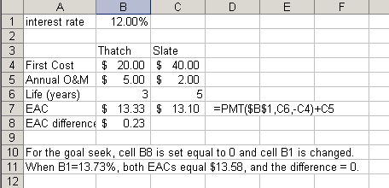

8-36
